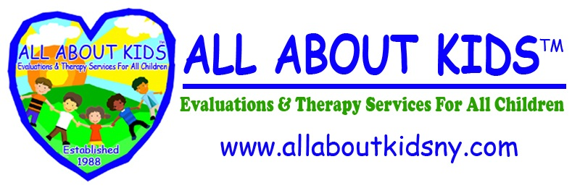

Speech Referral for Evaluation or Recommendation for Services

(You must use a separate form for each.)

A Speech and Language referral for an evaluation or a recommendation for services is recommended in accordance with the request by Early Intervention.

Services, when provided, will be in accordance with the Individualized Family Service Plan.

Student Name: _________________________________________________

Date of Birth: _________________________________________________

Provider: _________________________________________________
(Agency, Center based Program or Individual Provider)

Period of Service: ____________________________________________

Diagnosis (ICD 10 code) REQUIRED for Services provided on or after 10/01/2015.

Diagnosis (ICD 9code) REQUIRED for Services provided prior to 10/01/2015.

□ EVALUATION
Reason for Evaluation: ___________________________________________________
Use the ICD9 code prior to 10/01/2015, the ICD-10 code for evaluations 10/01/2015 or later and describe the Presenting Problem if no diagnosis exists at time of evaluation.
□ SERVICES: ____________________________________________________
REQUIRED - Use as many ICD9 and ICD 10 codes as appropriate

- Use official ICD-10 code for services given 10/01/2015 or later
- Use official ICD-9 code for services given prior to 10/01/2015

____________________________________ *Signature:______________________
(Please Print Name) NYS Licensed Speech Pathologist

Medicaid provider Number: _______________

Date
License Number: ____________ NPI Number: _____________ Signed: ___________

Note: Medicaid requires that speech evaluations and services be recommended by a Licensed Speech Pathologist, Physician, Physician’s Assistant, or Nurse Practitioner prior to or on the date of the evaluation or the start of services.
*Must be original signature – Stamped Signature will not be accepted.

A FACSIMILE OR PHOTOCOPY OF THIS RECOMMENDATION IS ACCEPTABLE.

